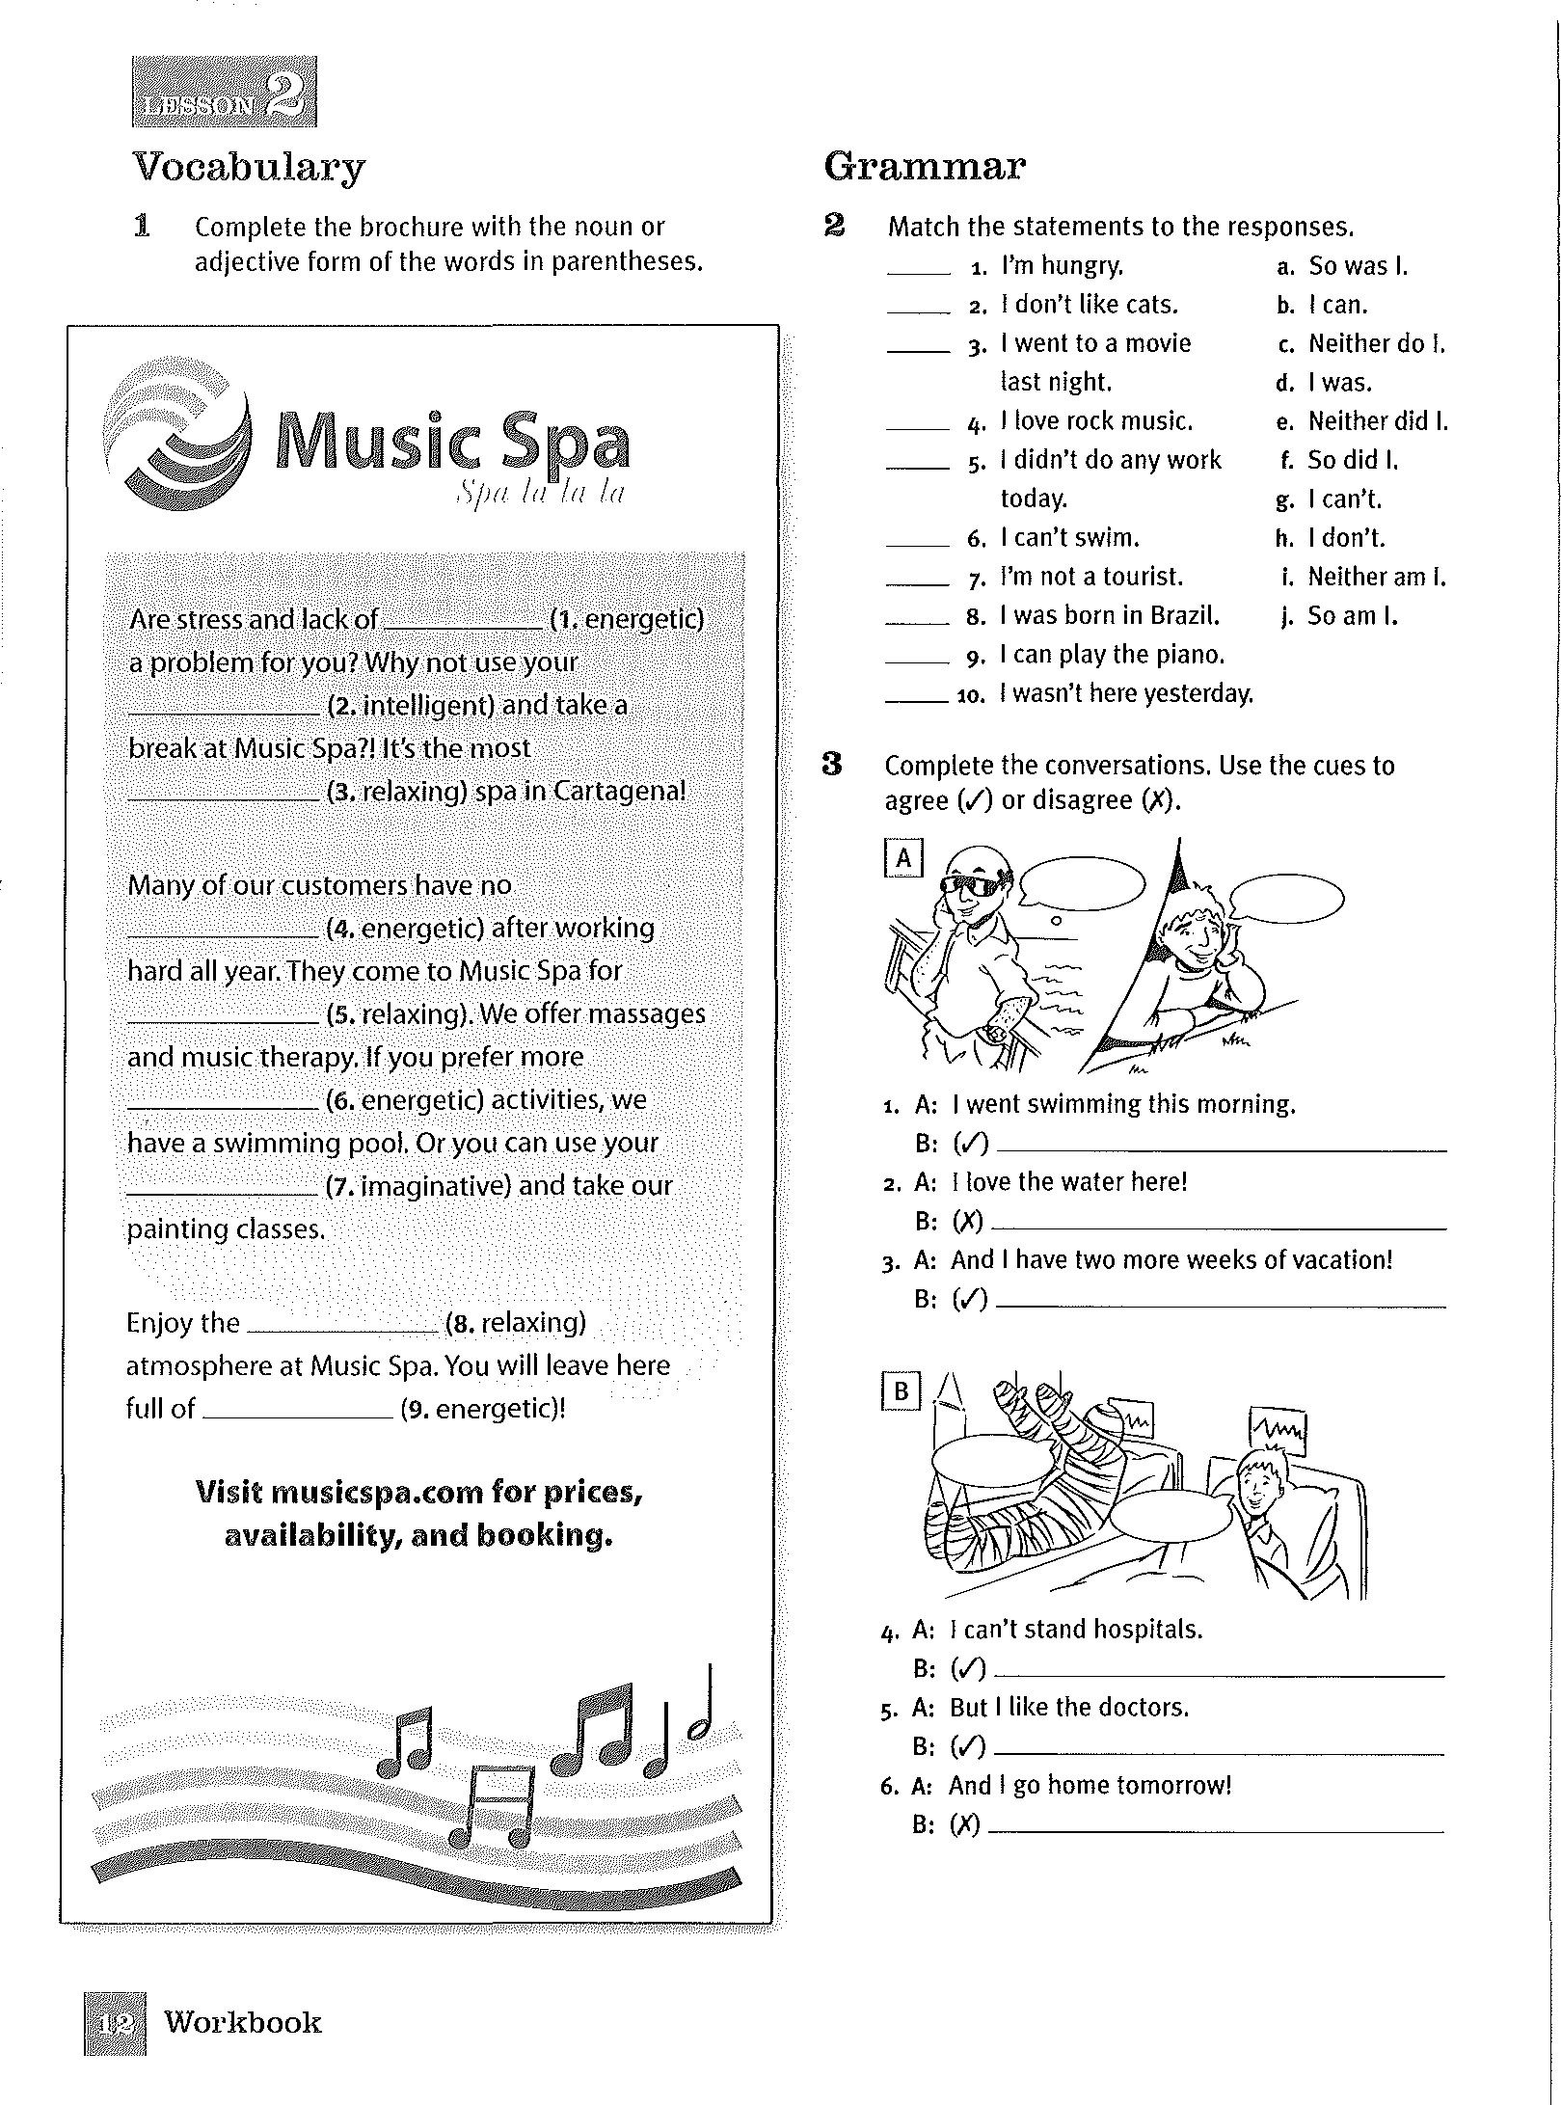

Energy

Intelligence

Relaxed

Energy

Relaxation

Energy

Imagination

Relaxed

energy